# Reports with Emp table

select JOB, DEPTNO,count(JOB) from emp

group by JOB,DEPTNO

Order by DEPTNO

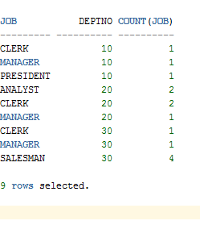

# Report view (Html)

